Experiment 1: Design of Clock Divider Circuit using RTL
Objectives:
- To design and verify a clock divider by two circuit using RTL (Verilog HDL) that generates a 50 MHz output clock from a 100 MHz input base clock.
- To design and verify a clock divider by four circuit using RTL (Verilog HDL) that generates a 25 MHz output clock from a 100 MHz input base clock.
- To implement flip-flop toggle logic for divide-by-2 operation and a 2-bit synchronous counter for divide-by-4 operation with active-high asynchronous reset.
- To perform behavioral simulation in Vivado Simulator (XSIM), measure output clock periods, and verify frequency division factors.
Required tools:
Xilinx Vivado Design Suite, Vivado Simulator (XSIM), PC or laptop.
Method:

(a) Generation of 50 MHz Clock from 100 MHz Clock (Clock Divider by 2)
1. Create a new RTL project in Xilinx Vivado targeting the appropriate FPGA device.
2. Add a Verilog module clock_divider_by2 defining ports: input wire clk, input wire rst, and output reg clk_out.
3. Write the RTL code using toggle logic (clk_out <= ~clk_out) triggered on the rising edge of clk or rst.
4. Create a testbench tb_clock_divider_by2 to generate a 100 MHz periodic clock signal (always #5 clk = ~clk;) and apply initial reset.
5. Run behavioral simulation using Vivado Simulator (XSIM) and observe the 50 MHz output clock waveform.

(b) Generation of 25 MHz Clock from 100 MHz Clock (Clock Divider by 4)
1. Create a new RTL project or add a new Verilog module clock_divider_by4.
2. Define ports: input wire clk, input wire rst, output reg clk_out, and internal 2-bit register reg [1:0] count.
3. Write the RTL code incrementing count on posedge clk and toggling clk_out when count reaches 2'b01.
4. Create a testbench tb_clock_divider_by4 to generate a 100 MHz clock signal and apply initial reset.
5. Run behavioral simulation using Vivado Simulator (XSIM) and observe the 25 MHz output clock waveform.
Program
- Clock Divider by Two Module

module clock_divider_by2 (
input wire clk,
input wire rst,
output reg clk_out
);
always @(posedge clk or posedge rst) begin
if (rst)
clk_out <= 1'b0;
else
clk_out <= ~clk_out;
end
endmodule
- Testbench Program for Clock Divider by Two

timescale 1ns / 1ps
module tb_clock_divider_by2;
reg clk;
reg rst;
wire clk_out;
clock_divider_by2 uut (
.clk(clk),
.rst(rst),
.clk_out(clk_out)
);
always #5 clk = ~clk; // 100 MHz clock generation
initial begin
clk = 0;
rst = 1;
#20 rst = 0;
#100;
$stop;
end
endmodule

- Clock Divider by Four Module
module clock_divider_by4 (
input wire clk,
input wire rst,
output reg clk_out
);

reg [1:0] count;

always @(posedge clk or posedge rst) begin
if (rst) begin
count <= 2'b00;
clk_out <= 1'b0;
end else begin
count <= count + 1'b1;

if (count[0] == 1'b1)
clk_out <= ~clk_out;
end
end

endmodule
- Testbench Program for Clock Divider by Four
`timescale 1ns / 1ps
module tb_clock_divider_by4;
reg clk;
reg rst;
wire clk_out;
clock_divider_by4 uut (
.clk(clk),
.rst(rst),
.clk_out(clk_out)
);
always #5 clk = ~clk; // 100 MHz clock generation
initial begin
clk = 0;
rst = 1;
#20 rst = 0;
#1000;
$stop;
end
endmodule
Observation table
Item | Parameter checked | Expected value | Observed value | Deviation (%)
1 | Input Clock Period (clk) | 10.0 ns | 10.0 ns | 0%
2 | Divide-by-2 Frequency (clk_out1) | 50.0 MHz | 50.0 MHz | 0%
3 | Divide-by-2 Clock Period | 20.0 ns | 20.0 ns | 0%
4 | Divide-by-4 Frequency (clk_out2) | 25.0 MHz | 25.0 MHz | 0%
5 | Divide-by-4 Clock Period | 40.0 ns | 40.0 ns | 0%
6 | Output Duty Cycle | 50% | 50% | 0%

Calculations
1. Clock Period Relationship: T = 1 / f
2. Frequency Division Formula: f_out = f_in / N
• Divide-by-2 Circuit: f_out1 = 100 MHz / 2 = 50 MHz ==> T_out1 = 20 ns
• Divide-by-4 Circuit: f_out2 = 100 MHz / 4 = 25 MHz ==> T_out2 = 40 ns
3. Percentage Frequency Deviation: Deviation (%) = | (f_simulated - f_theoretical) / f_theoretical | * 100
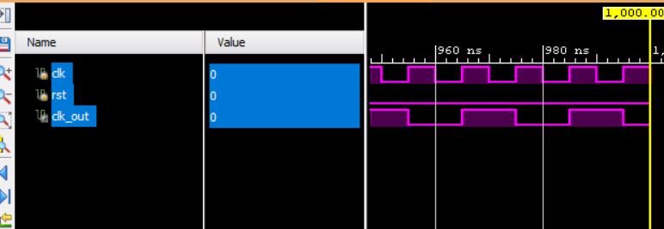
Figure 1: Clock division by 2
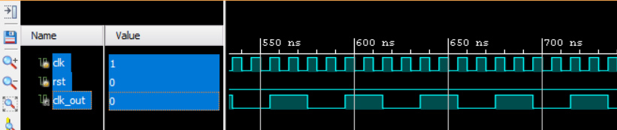
Figure 2: Clock division by 4

Conclusion
The two clock-divider variants were described in Verilog RTL and tested with Vivado XSIM. The output waveforms corresponded to 50 MHz for divide-by-2 and 25 MHz for divide-by-4, giving periods of 20 ns and 40 ns. These observations agree with the required division ratios.

